Data Technician Workbook
Week 1: Excel

Name:
Course Date:
Table of contents
Day 1: Task 1 2
Day 2: Task 1 2
Day 2: Task 2 3
Day 2: Task 3 4
Day 3: Task 1 4
Day 3: Task 2 5
Dataset: 5
Step 1: Create a Pivot Table 5
Step 2: Use the SWITCH Function 5
Submission: 6
Day 3: Task 3 6
Day 4: Task 1 7
Course Notes 9
Additional Information 10

Day 1: Task 1

Please research and complete the boxes below on common laws and regulations that must be followed when working with customers' data, and use the below bulleted list to support your answers.

- What is it
- Why is it important
- Provide a real-world example of how you can follow it
- How does it impact working with data
- What could happen if you breached it

Data Protection Act | - The Data Protection Act is the law that governs the rules and regulations of organisations that collect, store, and use personal data.  The Data Protection Act sets out rules on how organisations or companies must handle personal data. This ensures that information is correctly stored and processed, and also that individuals have rights over the information held on the system.  - The rules and regulations are put into place to ensure that only the right people have access to the information to prevent data leaks, which could result in identity theft, cyberattacks, and also prevent costly fines if the information gets into the wrong hands.  - You will sometimes receive an email presenting as the bank and instructing you to follow a link to confirm personal account details to prevent fraud. You need to follow the correct steps: the bank will never send an email like that. You should also call the bank using the phone number on the back of the card; this ensures that only the right people have access to your account. I will also need to ensure that I remove all my personal details when disposing of letters with any personal information.  - You can lose your job if you misuse the data or, even worse, commit a serious crime that involves law enforcement.  Data protection: The UK's data protection legislation - GOV.UK  Data Protection Act 2018
G | General Data Protection Regulation (GDPR) is the EU that controls how organisations collect, use, store, and protect personal data. GDPR has a significant impact on working with data and directly affects how you design databases, write SQL queries, and share information within an organisation.  For example, while working in IT support, different departments may raise incidents requesting information. You must ensure that you provide the correct information to the appropriate department. For instance, if a department is analysing trends, the SQL query should respect privacy by reporting aggregated data, such as user counts, without exposing individuals' names or other personal information.  What does the GDPR mean for business and consumer technology users - GDPR.eu
Freedom of Information Act | “The Freedom of Information Act 2000 is a UK law that gives the public the right to access information held by public authorities”. It allows individuals to request information from public organisations and authorities, promoting transparency and accountability.  In one of my previous roles, I was required to obtain Security Check (SC) clearance. Before my interview, I also requested information held about me by the NHS. Accessing this information helped me understand what data was held about me and enabled me to prepare for the SC interview.  Freedom of Information Act 2000

Day 2: Task 1

Please research and complete the following tasks within the retail-sales_dataset.xlsx document, and paste a print screen into the provided boxes below:

- In the sheet ‘retail_sales_dataset’, add all available data between columns A – H into a ‘table’ using Ctrl+T. Then name the table.
- Using the ‘filter’ function, filter ‘Age’ from ‘largest to smallest’
- Using the ‘SUM’ function, show me the commission total in cell ‘P10’
- Using the ‘AVERAGE’ function, show me the average commission in cell ‘P11’

Print screen 1 | 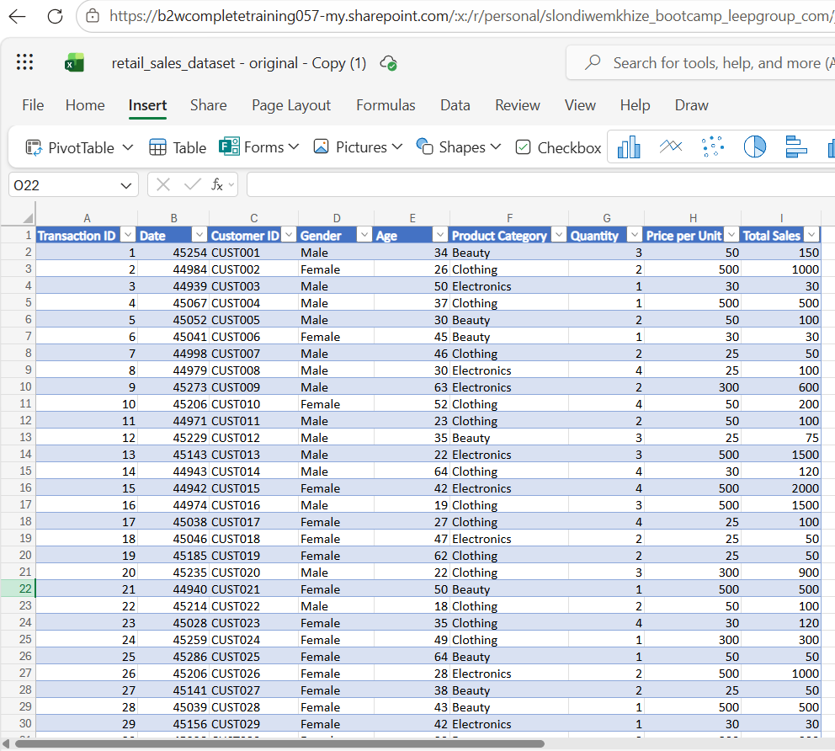
Print screen 2 | 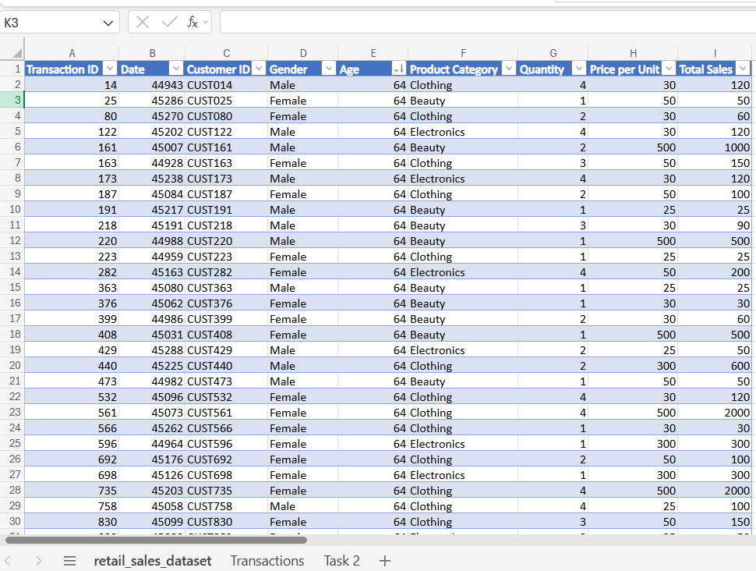
Print screen 3 | 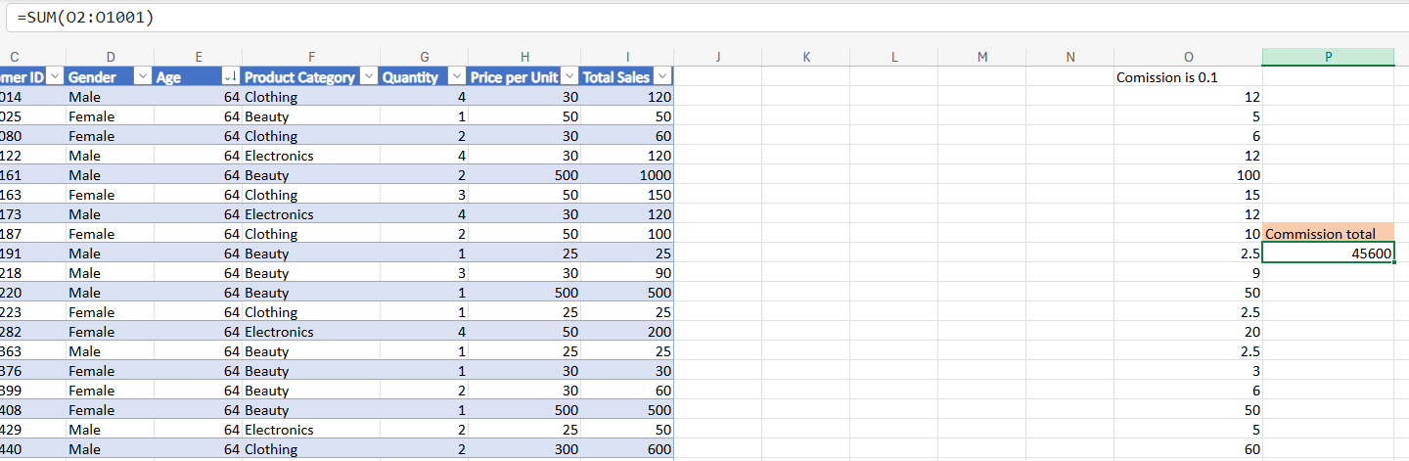
Print screen 4 | 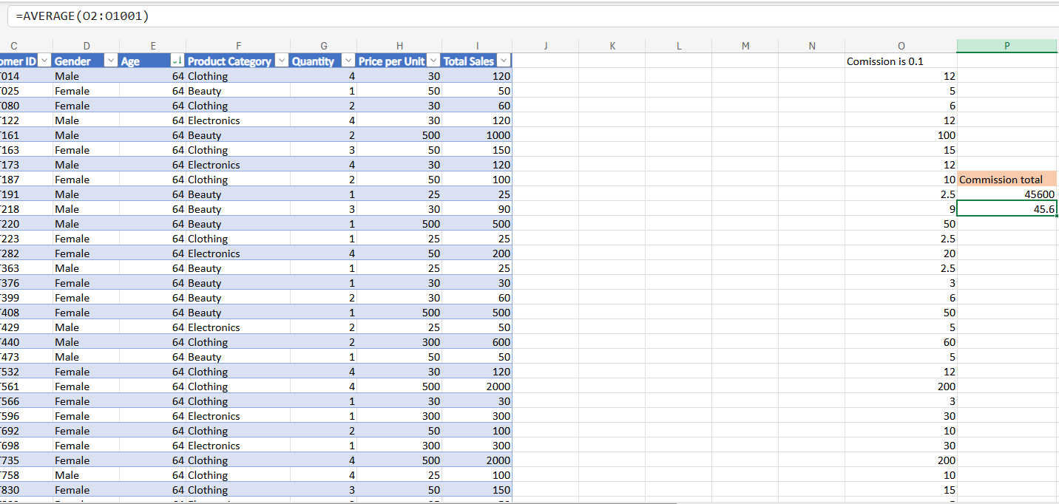

Day 2: Task 2

Please research and complete the following tasks within the document, and paste print screens into the provided box below:

Use the Student grades table provided by the tutor,

Convert the table to an Excel table. (Ctrl +T)

Student name | English | Mathematics | Science | Average | Highest score
Carol | 75 | 85 | 85
Khan | 85 | 75 | 80
Harry | 80 | 70 | 80
Sarah | 80 | 70 | 80
John | 65 | 80 | 70
Linda | 90 | 50 | 70
Edward | 55 | 80 | 60
Mary | 55 | 70 | 65
Thomas | 55 | 30 | 65

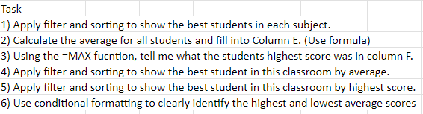

Print screen 1 | 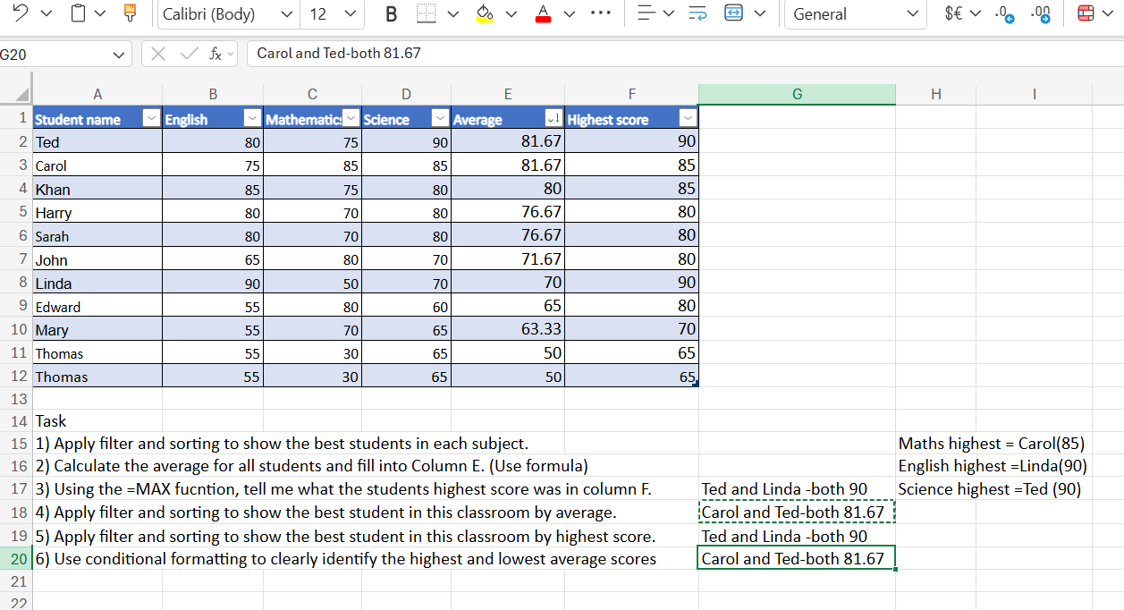

Day 2: Task 3

Using the skills developed today, have some fun with the data set you have imported. Paste your work below and enjoy!

Print screen 1 | 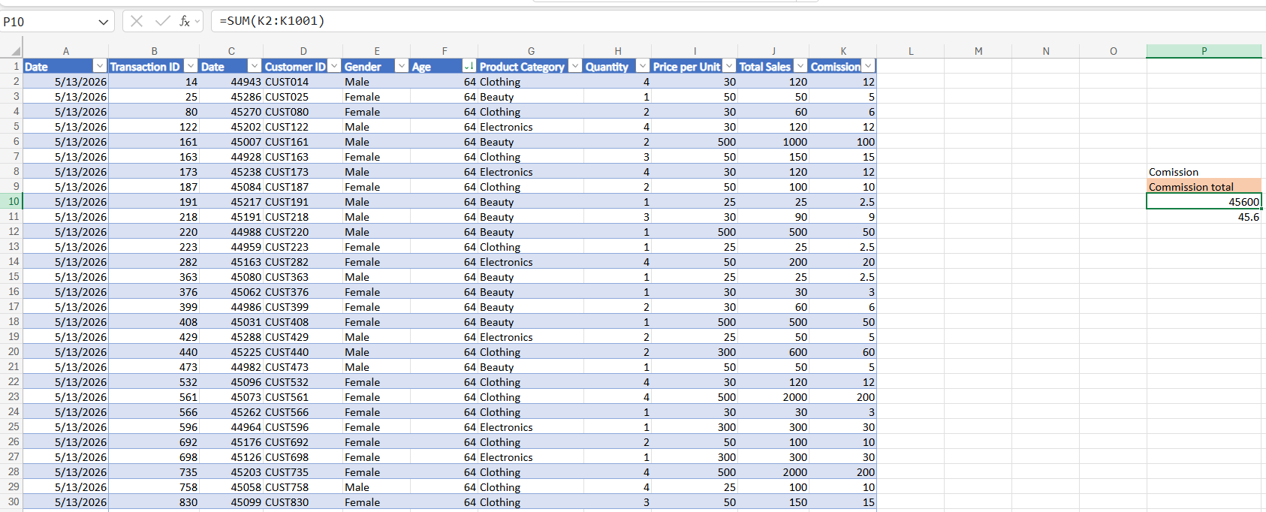

Day 3: Task 1

Dataset: Day_3_Task_1_Bike_Sales_Pivot_Lab.xlsx. and,
Lab instructions: Lab pivot table use for task 1 instructions

Make a copy of the dataset. Use the copy.

Convert to Excel Table (Ctrl +T)

Follow the lab instructions. Do not worry if you do not complete the lab; just working with data and playing with the pivot table will be a good experience.

Note:
Under refine the pivot table:
To mask 0's.
Click the pivot table
Click the Pivot Table Analyse tab on the menu bar.
Options > options > layout and format> In the field for empty cells, select the checkbox and enter 0 (zero). Ok.

And for the reflection questions, please do them in your workbook, not in the lab. 😊

Please paste your final pivot table below and complete the reflection questions:

Print screen 1 | 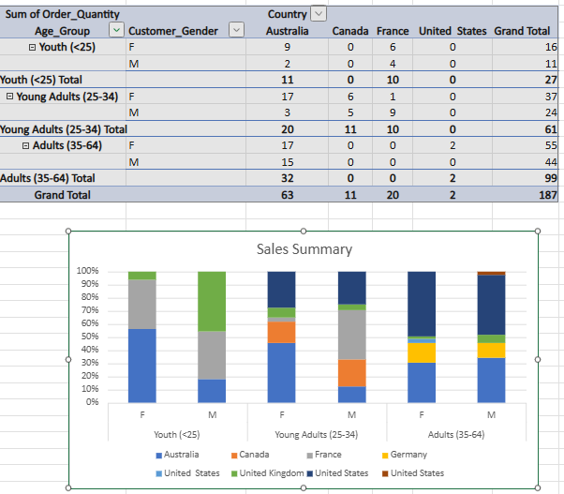  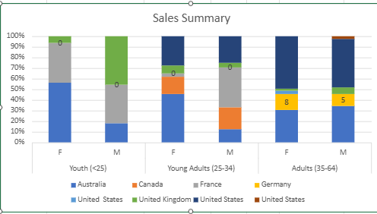
In which markets does Germany have customers? | Germany currently has customers in:  - Male Adults (35–64)  - Female Adults (35–64)  There are no sales in the Youth and Young Adults category for both male and females customers.
What country has sales in all markets? | 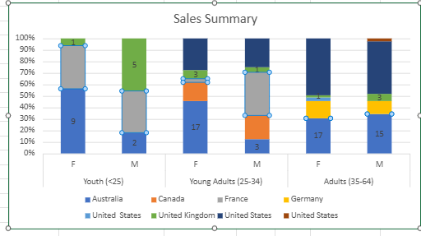  Looking at the graph, Australia has the highest sales across all market segments. When analysing the data, it appears that the United Kingdom also has sales across all market segments, but not to the same extent as Australia.
What are the most profitable markets by country, age group, and gender? | Country: Australia has the highest sales overall.  Age Group: Adults (35–64) were the highest age group to generate sales overall.  Gender: Female customers, particularly Adult females (35-64) represented the strongest.
Any other findings? | While analysing the pivot table, France shows no sales for adult males, which may indicate a potential gap in the company's marketing strategy. The data also shows that adult customers are the company's primary customer base, contributing to the majority of overall sales.

Day 3: Task 2

The dataset below tracks the sales performance of different products in various counties in England. Please paste the dataset into a blank Excel workbook. Your task is to:
- Create a Pivot Table to summarise the data by county and product.
- Use the SWITCH function to categorise products based on their sales volume.
See instructions below.

The dataset can be found in the last workbook you used.

County | Product | Sales Volume
Yorkshire | Laptops | 500
Yorkshire | Smartphones | 200
Cornwall | Laptops | 700
Cornwall | Printers | 400
Lancashire | Smartphones | 150
Lancashire | Laptops | 600
Essex | Printers | 800
Essex | Smartphones | 300
Durham | Laptops | 250
Durham | Printers | 300
Greater Manchester | Smartphones | 600
Greater Manchester | Laptops | 400

Dataset:

Step 1: Create a Pivot Table
- Select the dataset (columns A to C).
- Insert a Pivot Table to summarise the data by County in the rows and Products in the columns. Use Sales Volume as the value to be summarised.

Step 2: Use the SWITCH Function
In a new column next to your data, use the SWITCH function to categorise products based on Sales Volume as follows:
For sales greater than 600: "High"
For sales between 300 and 600: "Medium"
For sales less than 300: "Low"

SWITCH Function Example:
=SWITCH(TRUE, C2 > 600, "High", C2 >= 300, "Medium", "Low")

- Apply this formula to each row, and check if the products are categorised correctly.
- In ‘Sales Volume’, you need to remove the space after each amount – hidden spaces
- Confirm the data type is numerical

Submission:
- A completed Pivot Table summarising sales by county and product.
- A new column in the dataset categorising products by sales volume using the SWITCH function.
  - Please paste your completed work below

Print screen 1 | 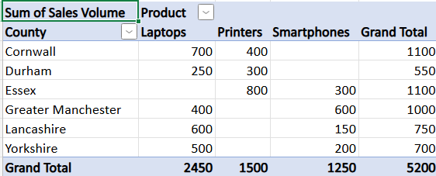  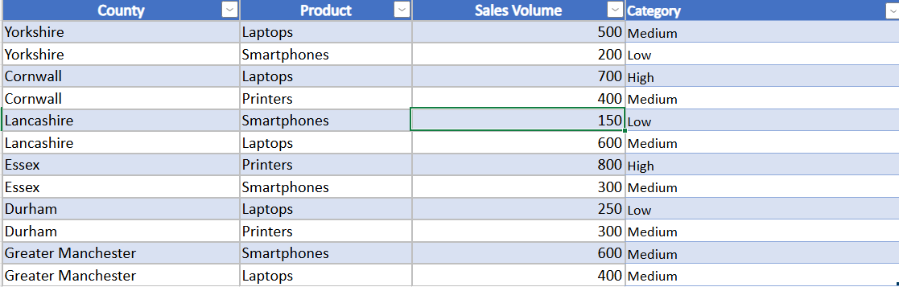

Day 3: Task 3

Please download the dataset ‘Day_3_Task_3_Bike_Sales_Visualisations_Lab.xlsx’.
Also, download the lab instructions.

Pivot tables are already created; you will need to create the pivot charts.

Follow the lab instructions.

Do not worry if you do not complete the lab; just working with data and playing with the charts will be a good experience.

Please paste your results below:

Print screen 1 | 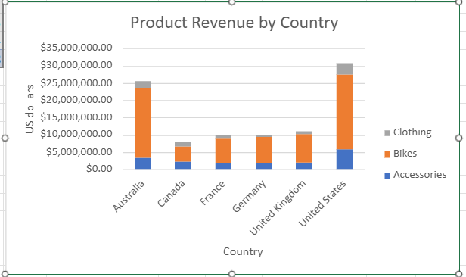  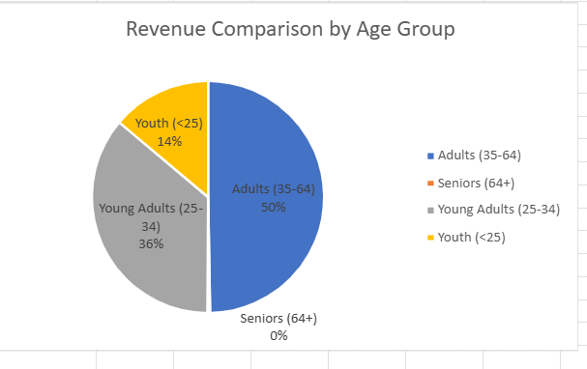

Day 4: Task 1

You have been asked to deliver your analysis findings to the board of directors. Within your analysis, you have identified that customers are leaving your company at the 12-month point, which is typically when they receive their renewal price.

Choose a business or organisation to focus your findings on.

Conduct research and complete the following questions:

As in all work situations, you can use AI Gen tools for research: it needs to be in British English, check spelling, grammar and maths; and written in your voice, not copied directly from the tool.

How would you prepare for the delivery? | I have chosen Allianz Online Car Insurance. Before delivering my presentation, I will thoroughly research the car insurance market, including competitor pricing, to ensure that I have accurate and up-to-date information to present to the Board of Directors.  My presentation will focus on customer retention, business performance, and practical recommendations for improving customer retention. I will create a PowerPoint presentation using charts and graphs to illustrate my findings, particularly in relation to the 12-month renewal point, making it easier for the Board of Directors to follow and engage with the presentation.  I will examine the financial impact of customers leaving at the 12-month renewal stage. In addition, I will analyse data collected from customer surveys to identify the reasons why customers choose not to renew their insurance. Based on these findings, I will make recommendations on how Allianz can improve customer retention and increase profitability.
What tools would you use for the delivery? | I will use Microsoft PowerPoint to create my presentation for the Board of Directors, incorporating charts and graphs to demonstrate my findings regarding customer turnover at the 12-month renewal stage. I will use Microsoft Excel to analyse customer data and produce charts and graphs that illustrate trends in policy renewals and cancellations based on my findings.  To ensure that my work is securely stored, I will save a copy of my presentation to Microsoft OneDrive and keep a backup copy on a USB drive.
What is prospecting, and why would you complete this before your delivery? | Before delivering my presentation to the Board of Directors of Allianz Car Insurance, I need to complete the prospecting process, which involves researching and gathering relevant information. This will help me understand what information is required for the Board of Directors to make informed decisions.  Completing the prospecting process before the presentation ensures that the content is relevant, accurate and tailored to the audience. It also enables me to answer questions confidently, present evidence-based recommendations, and increase the likelihood that the Board will support the proposed actions.
Tell me the best practices for public speaking and providing updates to senior leaders | When presenting my findings to the board of directors at Allianz Car Insurance, I would need to speak clearly and confidently, focusing on the increase in customer loss at the 12-month renewal stage.  I would use graphs and charts to support the data, explain the financial impact on the business and recommend actions such as offering more competitive renewal prices and loyalty rewards.  Engage with the Board of Directors by inviting questions, listening carefully, and responding respectfully.  - Prepare for potential questions by anticipating areas of concern and supporting your answers with evidence.  - Use charts and graphs to support your findings with clear and reliable evidence.  - Maintain confident body language throughout the presentation to demonstrate professionalism and credibility.  - Explain how your recommendations, such as improving renewal pricing or introducing customer loyalty rewards, could reduce customer turnover and improve profitability.  17 Proven Ways CEOs Can Improve Impromptu Public Speaking Skills
What will you show the board in your delivery? | 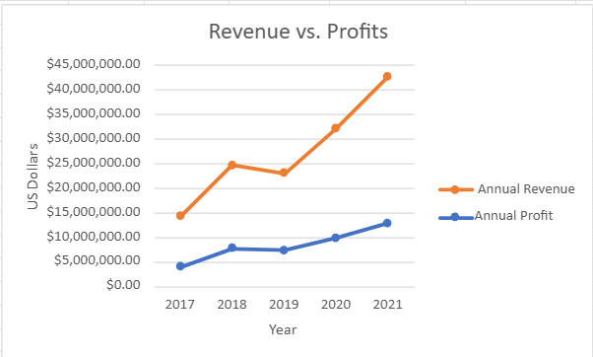
How will you articulate the changes that are needed? | I would begin by explaining that many customers are choosing not to renew their policies after 12 months because they receive higher renewal premiums or find better offers from competitors. I would then use charts and graphs to demonstrate the increase in customer loss at the renewal stage and explain the financial impact on the business.
Provide a list of online resources and videos that will support your preparation for public speaking | PowerPoint help & learning | Microsoft Support  TED Talks  LinkedIn Learning: Online Courses for Creative, Technology, Business Skills  Home - BBC Bitesize
Evaluate tools that provide visualisation.  Tell me what they are.  Tell me what you would choose when delivering your presentation and why | For my presentation, I would choose Microsoft PowerPoint supported by Microsoft Excel. I would use Excel to analyse customer data and create charts showing the increase in customer loss at the 12-month renewal stage. These charts would then be inserted into PowerPoint, allowing me to present the findings in a clear and professional manner.  I chose PowerPoint because it enables me to present my findings clearly using bullet points, charts and graphs, helping to keep the board of directors engaged. Using visualisations created in Excel also makes it easier for senior leaders to understand customer trends and the financial impact of customers leaving after 12 months.

Course Notes

It is recommended to take notes from the course, use the space below to do so.

Additional Information

We have included a range of additional links to further resources and information that you may find useful, these can be found within your revision guide.

END OF WORKBOOK

Please check through your work thoroughly before submitting and update the table of contents if required.

Please send your completed work booklet to your trainer.

